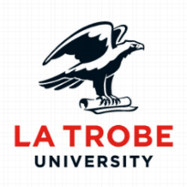
Remuneration and Performance Management
Assignment 2: Individual Project

Name:
Student Number:

Subject Code: MGT3RPM
Facilitator’s Name:
Seminar Day and Time:

Word Count:
Due Date:

Employee Performance and Development Review Instruction Manual for Coca-Cola Company.

Coca-Cola Employee Performance and Development Review Instruction Manual
(Instructions: Update the Table of Contents page once you have finished writing this report - do this by hovering over the Table of Contents, right click, and then select update field – select update page numbers only and press ok)
Table of Contents
OVERVIEW OF COCA-COLA COMPANY 2
PERFORMANCE REVIEW STAGES 3
Monitoring: 4
Informal Feedback: 4
Formal Assessment: 4
Formal Review Meeting: 4
Action Planning: 5
Learning and Development: 5
MEMO FOR EMPLOYEES 5
TRAINING MANUAL FOR MANAGEMENT 7
COCA-COLA COMPANY EMPLOYEE PERFORMANCE REVIEW FORM 10
FEEDBACK GUIDE FOR MANAGEMENT 11
REFERENCES 14

OVERVIEW OF COCA-COLA COMPANY
Describe the organisation – a brief overview of approximately 150 words
Coca-Cola is a multinational company that is specialised in producing beverage products, whose headquarter is in Atlanta (Brondoni, 2019). There are many Coca-Cola branches in different locations, making it the largest and most successful beverage company in the world. The company has been recognised worldwide for its unique products for many years. Coca-Cola products are distributed to every location through supermarkets, wholesalers and retailers to make them available to all consumers. Making products available to customers makes Coca-Cola increase its sales and customer loyalty. Coca-Cola’s most significant problem is high competition in the beverage industry from fast-growing companies like Pepsi. The increase in Coca-Cola wastes such as plastic bottles exposes the company to a more significant challenge because it pollutes the environment. Coca-Cola aims at maintaining customer loyalty and satisfaction by providing quality products to the market, which is achieved through innovation (Brondoni, 2019). The company also aims to be the leader in offering beverage products, maximizing profits and maintaining consistent long-term growth in the industry.

PERFORMANCE REVIEW STAGES
Provide a description of the stages in the Employee Performance Review process (approx. 300 words)
The performance review process refers to the evaluation of an employee’s performance in the real working environment by a manager (Kanket, 2019). The process involves creating performance standards that should be achieved and communicating them to employees. The manager communicates the performance expectations required from the employees. The actual performance of employees is measured and compared with the set standards. The employees are involved in the discussion of the results and the correct action is taken

Monitoring:
Monitoring involves watching the employee's performance and progress. Employees should be monitored continuously to determine how they perform tasks towards the achievement of results (Van & Reichard, 2018). Managers should focus more on the achieved results and the possible factors that may affect the working environment. Managers should also note the development of employees. Any corrections that are needed to improve the performance should be done.

Informal Feedback:
Informal feedback refers to the casual conversation with employees concerning their behaviours and performance. Managers provide come comments such as “good job” or “I appreciate your hard work.” Informal feedback plays an essential role in appreciating the work done by the employees (Van & Reichard, 2018). Employees also get motivated since the managers recognise their efforts. Therefore, employee performance is easily achieved because there is clarity and enforcement of good behaviors.

Formal Assessment:
Formal assessment refers to the regular evaluation of employees in a company (Van & Reichard, 2018). Formal assessment is done to determine what is done right or wrong by the employees. Evaluation maybe is done annually or semi-annually. Formal assessment is usually done to help employees understand what they have been doing and areas they should focus on. The employees are also given the opportunity for improvement by working on their weaknesses and major in their strengths.

Formal Review Meeting:
A formal review meeting refers to the annual review of employees’ performance, which is carried out by the company’s manager (Van & Reichard, 2018). A formal written report about each employee is prepared once a year during the same period. Usually, positive feedback about the employees is provided in their profiles. A formal review meeting aims at discussing how employees should be developed in their working environment for better performance.

Action Planning:
Action planning refers to a well-arranged and detailed plan that all actions are based on helping employees improve their performance. This type of plan allows employees to get back on their track. In most cases, it is used to address deficiencies or failures in the performance or behaviors of the employees. According to Van and Reichard. (2018), the employee is provided with an opportunity to make improvements for success.

Learning and Development:
Employee learning and development aim to improve the performance of employees in their jobs by focusing on their growth (Van & Reichard, 2018). Learning refers to programs aimed at helping employees gain specific skills and knowledge for better performance in an orgoanization. Learning and development improve the workforce’s morale and help them understand the organisational goals. Employees get equipped with the necessary skills and knowledge that is applied in the actual work environment.

MEMO FOR EMPLOYEES
Write a memo from the Human Resource Manager to all employees outlining the Employee Performance Review process (approx. 200 words)
Dear Team Coca-Cola,
I am writing to let you know that the current employee performance reviews in the company will change. The changes are scheduled to be effective starting from next month in all the Coca-Cola companies. The current performance review is done semi-annually and annually and this process will not be effective from next month. The new performance review process will be done quarterly, semi-annually, annually and 360 degrees. The new performance review process will involve all the employees in the company. The performance reviews will be targeting at improving the overall performance of the company by increasing employee engagement.
The reviews will be used by comparing with previous ones to determine improvements made within the periods. The quarterly performance reviews will effectively resolve the urgent changes or issues that need to be attended to. The reviews will help determine if there is a need for training of the employees. This activity will be important to the management to decide if company employees are ready to assume responsibilities if there are open promotion opportunities in the offices. The activity will also be targeting on assessment of salary increment based on the employee performance or seniority. The performance reviews will be used to strengthen the relationships among the staff and loyalty in the company. In case any questions or issues concerning the changes, feel free to seek consultation from the human resource office.

TRAINING MANUAL FOR MANAGEMENT

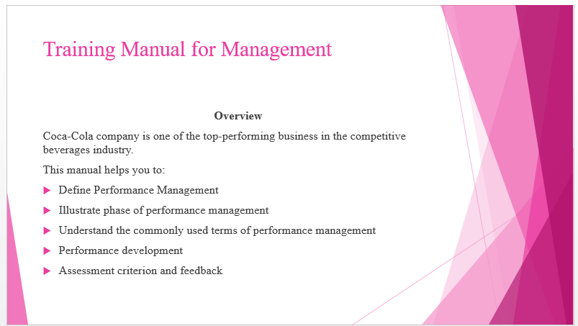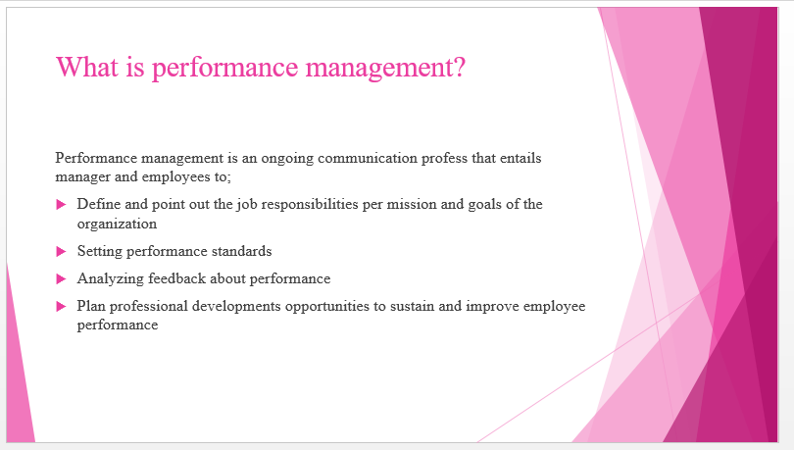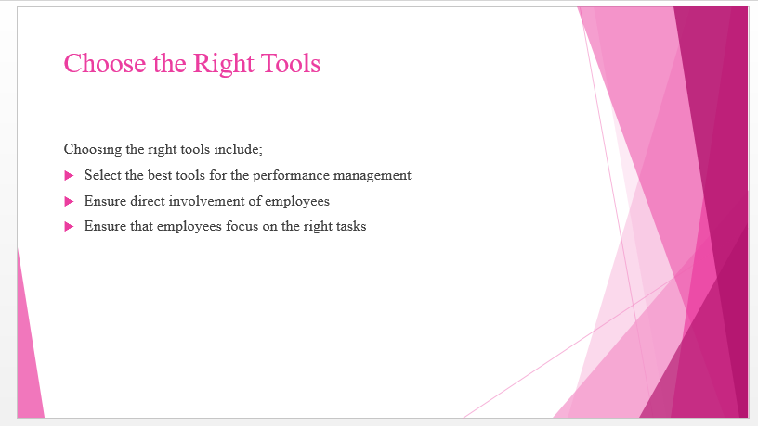
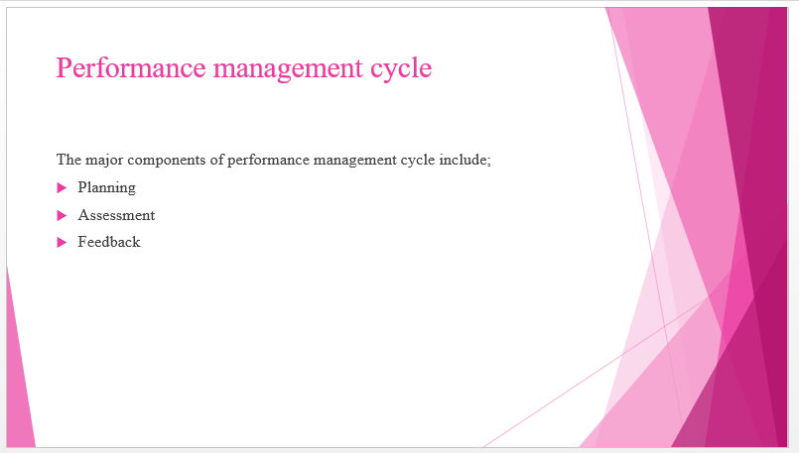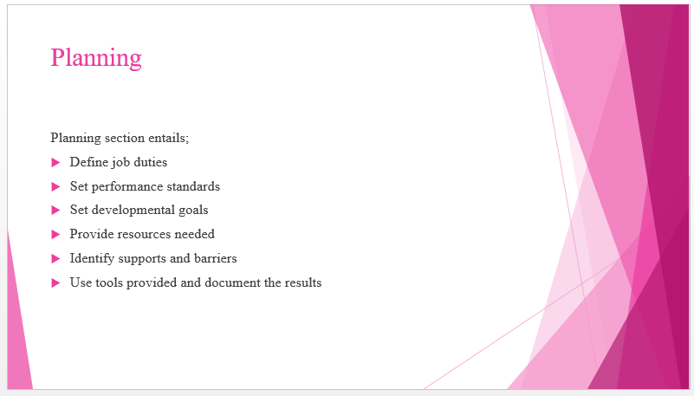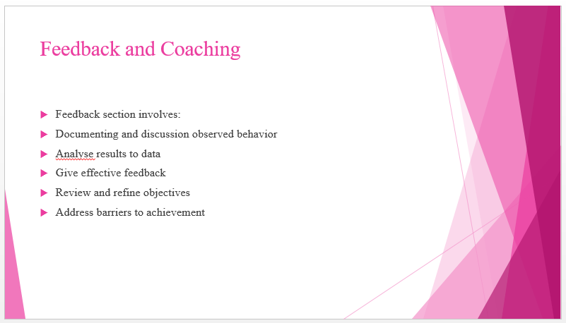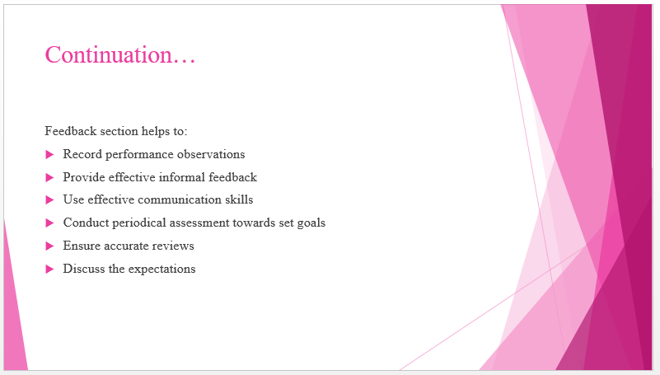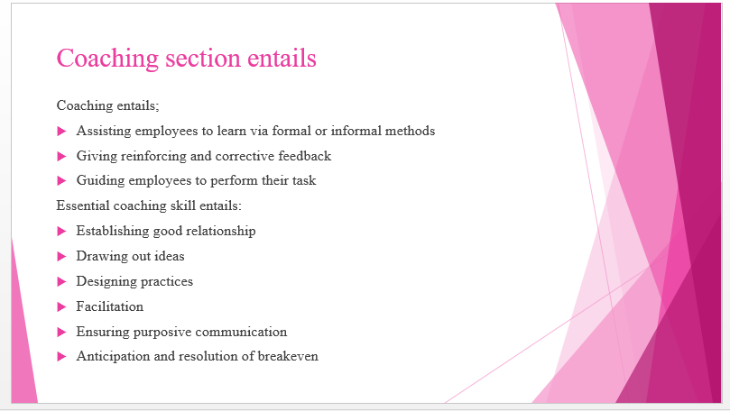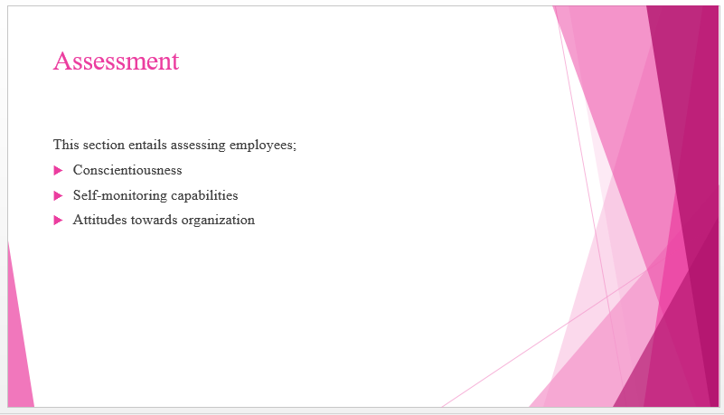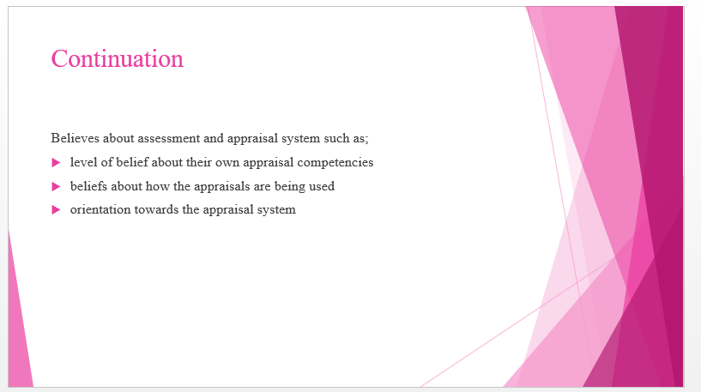

COCA-COLA COMPANY EMPLOYEE PERFORMANCE REVIEW FORM

Coca-Cola Employee Performance Review Form
Employee Details
Employee’s Name |  |  |  |  | Job Title
Employee’s ID |  |  |  |  | Reviewer’s Name
Job Position
Date of Hire |  |  |  |  | Review Date
Performance Evaluation
Instructions: Kindly complete this form for the quarterly, semi-annually or annually performance review. Suggestions for future improvements will be appreciated.
Codes: E= Excellent, G= Good, F= Fair and P= Poor.
Evaluation Area |  |  |  |  |  |  |  | Comments
Attendance
Punctuality
Communication ability
Creativity
Teamwork
Work Quality
Technical Skills
Dependability
Productivity
Honesty
Integrity
Additional Comments:

Employee Signature: Date: |  |  |  | Reviewers Signature: Date:

FEEDBACK GUIDE FOR MANAGEMENT
Negative feedback can contribute to poor management in an organisation. Therefore, it is important to ask the employee if they are ready to receive the feedback. According to Greve and Gaba. (2017), managers should ask when to provide feedback and it is always good to do it as quickly as possible. The feedback provided should always be relevant and factual. People should always determine the consequences from their comment to identify how relevant it is. In most cases, people are aware of when they have positive achievements and when not. It is essential to inquire if the employee is aware of what you are saying; therefore, an open mind is required.
Listening is one of the most valuable but difficult skills to master. It is essential to pay attention to the receiver by listening actively (Greve & Gaba, 2017). Active listening helps in rephrasing or asking questions that are open-ended before giving feedback. As a manager in an organisation, it is important to explain the feelings. At this point, the employees have a lot of freedom and time to express their views. The manager’s feelings and perception of the employee’s behavior or action are precious. Offer suggestions, which can be through brainstorming, to provide as many ideas as possible. The employee is invited into the open dialogue. At this time, a discussion about the consequences can be held, especially if there is still no solution to the incident. The suggestion and consequences step can take a written or verbal warning (Greve & Gaba, 2017).
Performance feedback is mainly used to develop or improve skills among individuals (Casas‐Arce et al., 2017). Feedback is essential in the performance management cycle because it contributes to the growth of employees. Employees are trained to get more skills that are essential in the performance of their job. In an organisation, the activities carried out are contributed by efforts from different people who work as a team. Therefore, when one of the employees gets performance feedback, all the other team members benefit too. As a result, the whole team benefits and transforms as one party, which gives it a common goal. When a team has a specific goal that it should work towards, the company's output is increased (Casas‐Arce et al., 2017). Performance feedback gives teams confidence in what they do and this creates morale. Individuals and groups are also provided with a wide range of options for better transformations.
Performance feedback would be important to Coca-Cola because it would help in the operation of the company activities. The feedback guide would be essential in providing the direction of the company to employees. Performance feedback affirms the employees that they are doing well in their work and gives them the direction to improve (Casas‐Arce et al., 2017). Employees would get the best possible suggestions to take for better performance. The feedback guide would also be important in enhancing a better relationship between the employees and the managers. Frequent interaction between managers and employees creates transparency, honest communication and trust. Therefore, the rate of employee turnover would most likely drop and build a better reputation for the company. A feedback guide also would eliminate guesswork since there is effective communication between the managers and employees. The company projects will be successful hence better general performance.

REFERENCES
Brondoni, S. M. (2019). Shareowners, Stakeholders & the Global Oversize Economy. The Coca-Cola Company Case. Symphonya. Emerging Issues in Management, (1), 16-27.
Casas‐Arce, P. A. B. L. O., Lourenço, S. M., & Martínez‐Jerez, F. A. (2017). The performance effect of feedback frequency and detail: Evidence from a field experiment in customer satisfaction. Journal of Accounting Research, 55(5), 1051-1088. A copy of the AoM guide is available on the LMS for your reference.
Greve, H. R., & Gaba, V. (2017). Performance feedback in organisations and groups: Common themes. The Oxford handbook of group and organisational learning, 1-45.
Kanket, W. (2019). Experimental research on employee performance review using knowledge management oriented OKRs approach in comparison to KPI approach.
Van Helden, J., & Reichard, C. (2018). Performance management. Global Encyclopedia of Public Administration, Public Policy, and Governance. Cham: Springer.

